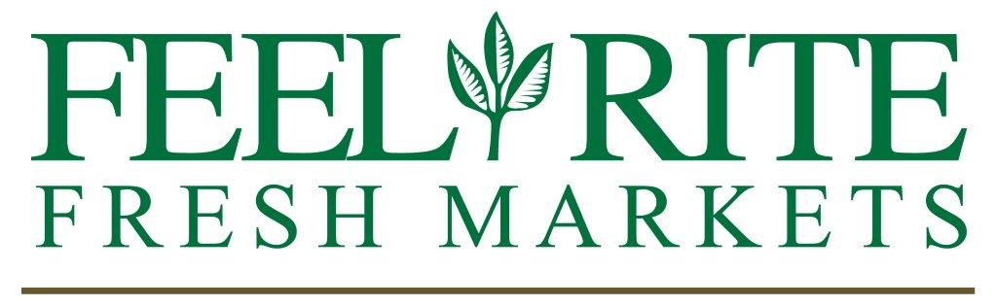

Return Policy:
To help ensure the safety of our customers and staff during the COVID-19 pandemic,
Feel Rite Fresh Markets will not accept any returns of all items purchased during, and for 30 days following the conclusion of the national state of emergency declared on March 1, 2020 in response to COVID-19; all sales are final.

Thank you for understanding, as we too look forward to resuming our normal standards and practices.

Limits: To help ensure we can serve the immediate needs of our customers, and minimize out-of-stock items, we currently have purchase limits on certain products.

